SIMATS ENGINEERING

ASSESSMENT TOOL I – RELATIONSHIP VISUALIZATION LAB
Course: Data Handling and Visualization | Code: DSA0603 | CO: CO4
Duration: 60 min | Total Marks: 50 | Reg No :  Name:

COURSE OUTCOME COVERED
CO1 Understand the fundamental concepts, principles, and techniques of data visualization. (BL3) Activity Tool : Relationship Visualization Lab
Weightage: 20%

Code of Conduct:
I V.P Sneha(192324284)(Name / Reg No) certify that this submission is my original work and that I have adhered to the guidelines specified for this assessment. I understand that any violation of academic integrity rules will result in disciplinary action.
Signature of the student: v.p sneha
Criteria | Selection of Relationship Visualization 25% | Relationship Analysis  25% | Application of Visualizati on Techniques 20% | Organization  15% | Accuracy  10% | Clarity 5% | Total
Q1
Q2
Q3
Q4
Q5

Relationship Visualization Lab

Provided Datasets
The following files are supplied alongside this document so the lab can be completed without internet access to install extra data packages:
- mtcars.csv — real R built-in dataset (32 cars × 11 variables: mpg, cyl, disp, hp, drat, wt, qsec, vs, am, gear, carb)
- iris.csv — real R built-in dataset (150 flowers × 5 variables: Sepal.Length, Sepal.Width, Petal.Length, Petal.Width, Species)
- gapminder2007_practice.csv — illustrative practice dataset in the style of the Gapminder 2007 cross section (country, continent, year, gdpPercap, lifeExp, pop). Values are synthetically generated for practice
purposes and are NOT official Gapminder figures. If internet access is available, students may instead run install.packages("gapminder") and use data(gapminder) for the authentic dataset.
- network_edges.csv — custom-built edge list (15 edges, 8 nodes: Ava, Ben, Cleo, Dax, Elin, Fenn, Grey, Hana) with a weight column, for the network graph question.
Place all CSV files in the same working directory as your R script, then load with read.csv("filename.csv").

Question 1: Scatterplot with Regression Diagnostics
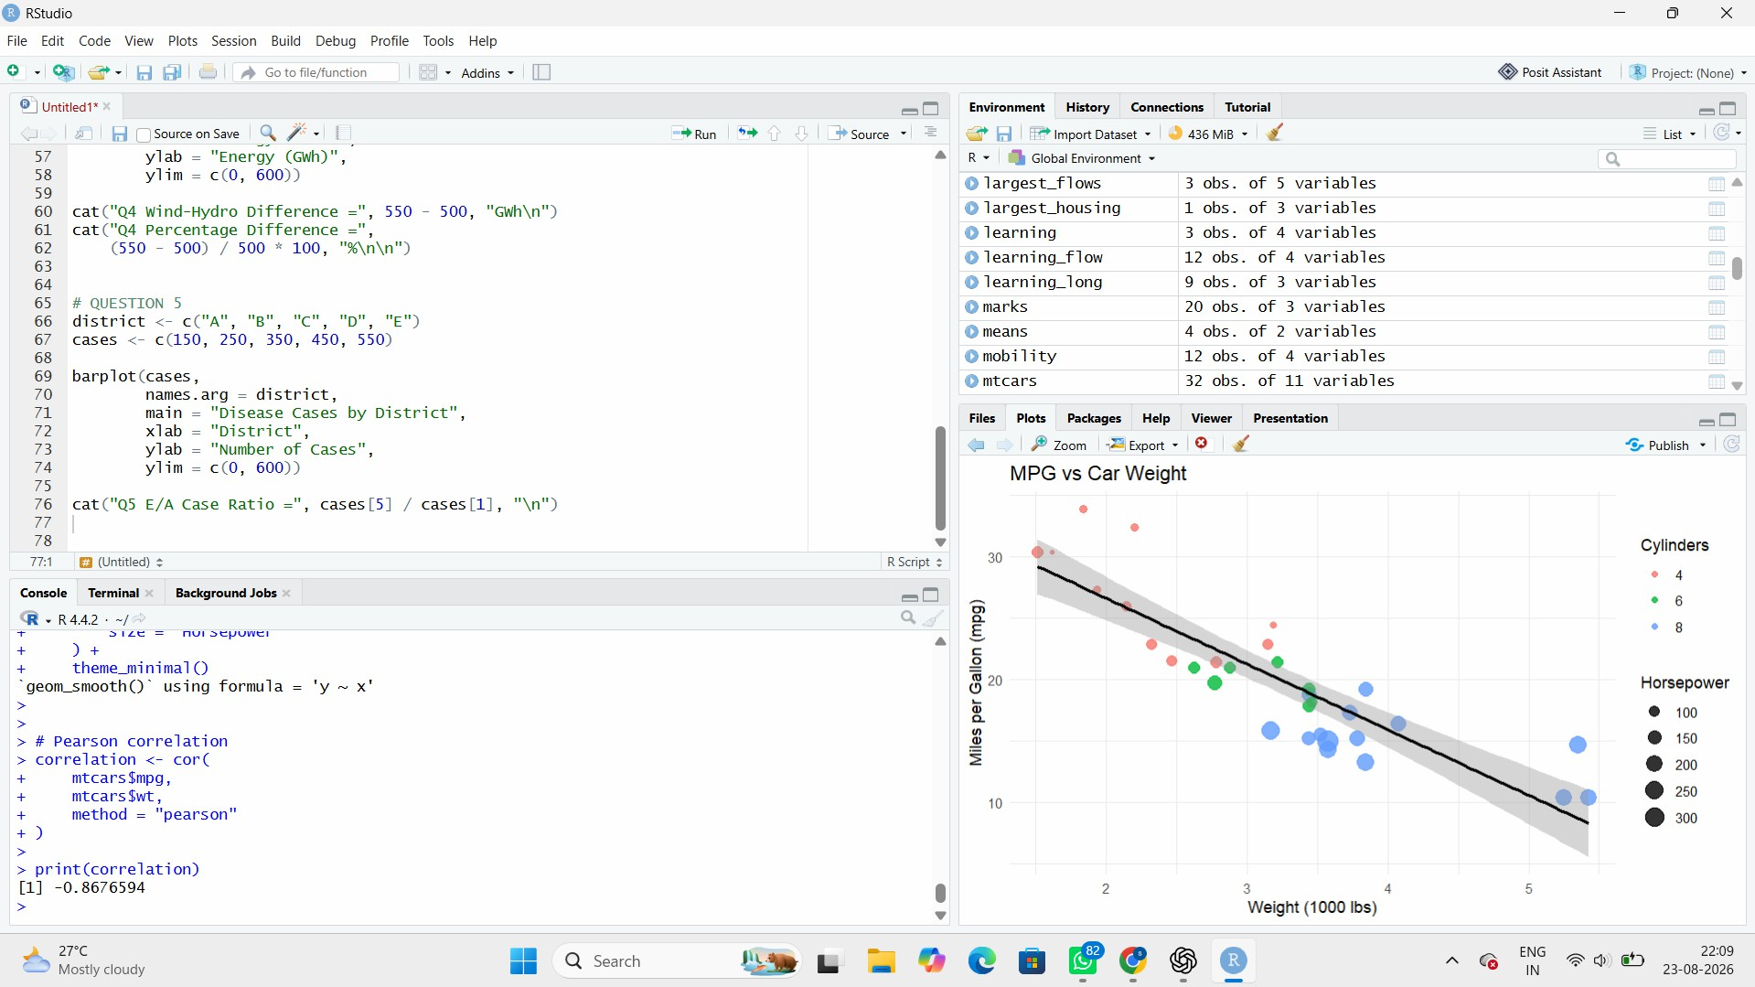
Interpretation
There is a strong negative relationship between car weight and fuel efficiency. As vehicle weight increases, mpg generally decreases. The correlation of approximately -0.868 indicates a strong inverse linear association.

Question 2: Correlogram Construction

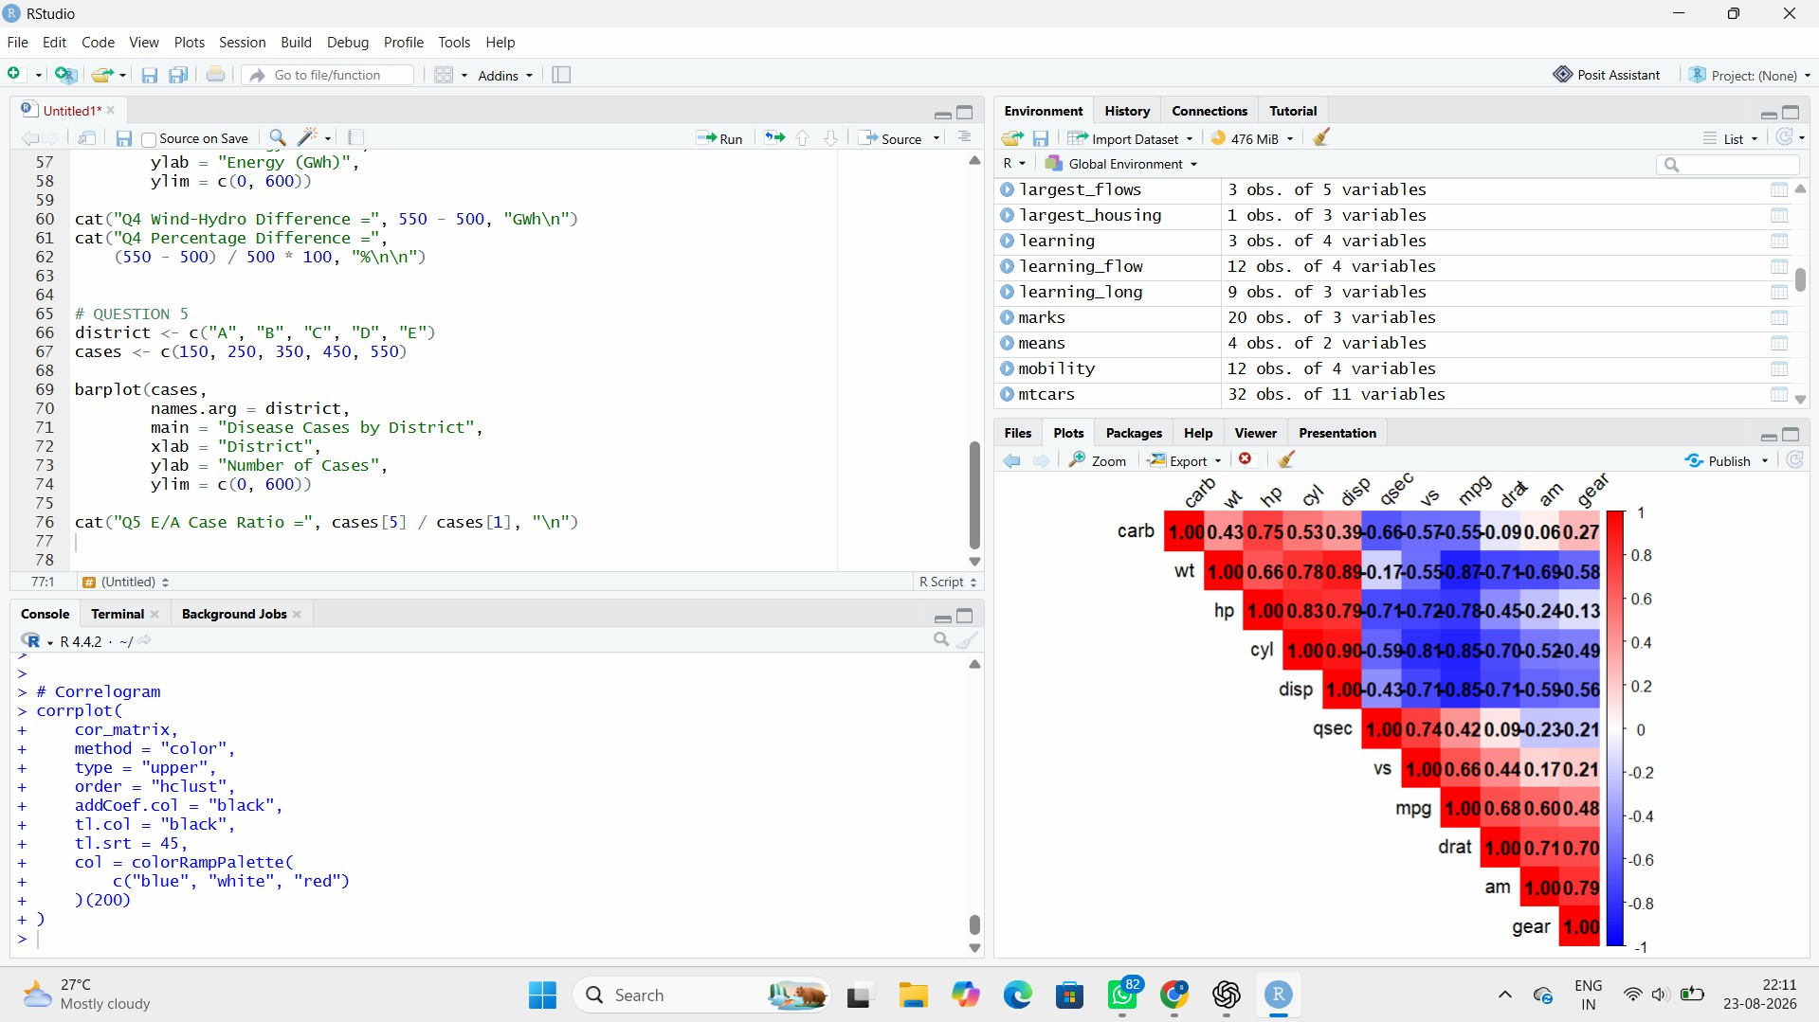

Strongest positive correlations

The strongest positive pairs include:
- cyl and disp ≈ 0.902
- cyl and wt ≈ 0.782
The strongest is:
cyl ↔ disp ≈ 0.902

Strongest negative correlation

The strongest negative relationship is:
mpg ↔ wt ≈ -0.868
Other strong negative relationships include:
- mpg ↔ cyl ≈ -0.852
- mpg ↔ disp ≈ -0.848
Conclusion

The correlogram shows that larger and heavier cars tend to have lower fuel efficiency, while variables such as cyl, disp, and wt are strongly positively related.

Question 3: Dimension Reduction Comparison (PCA vs. t-SNE)

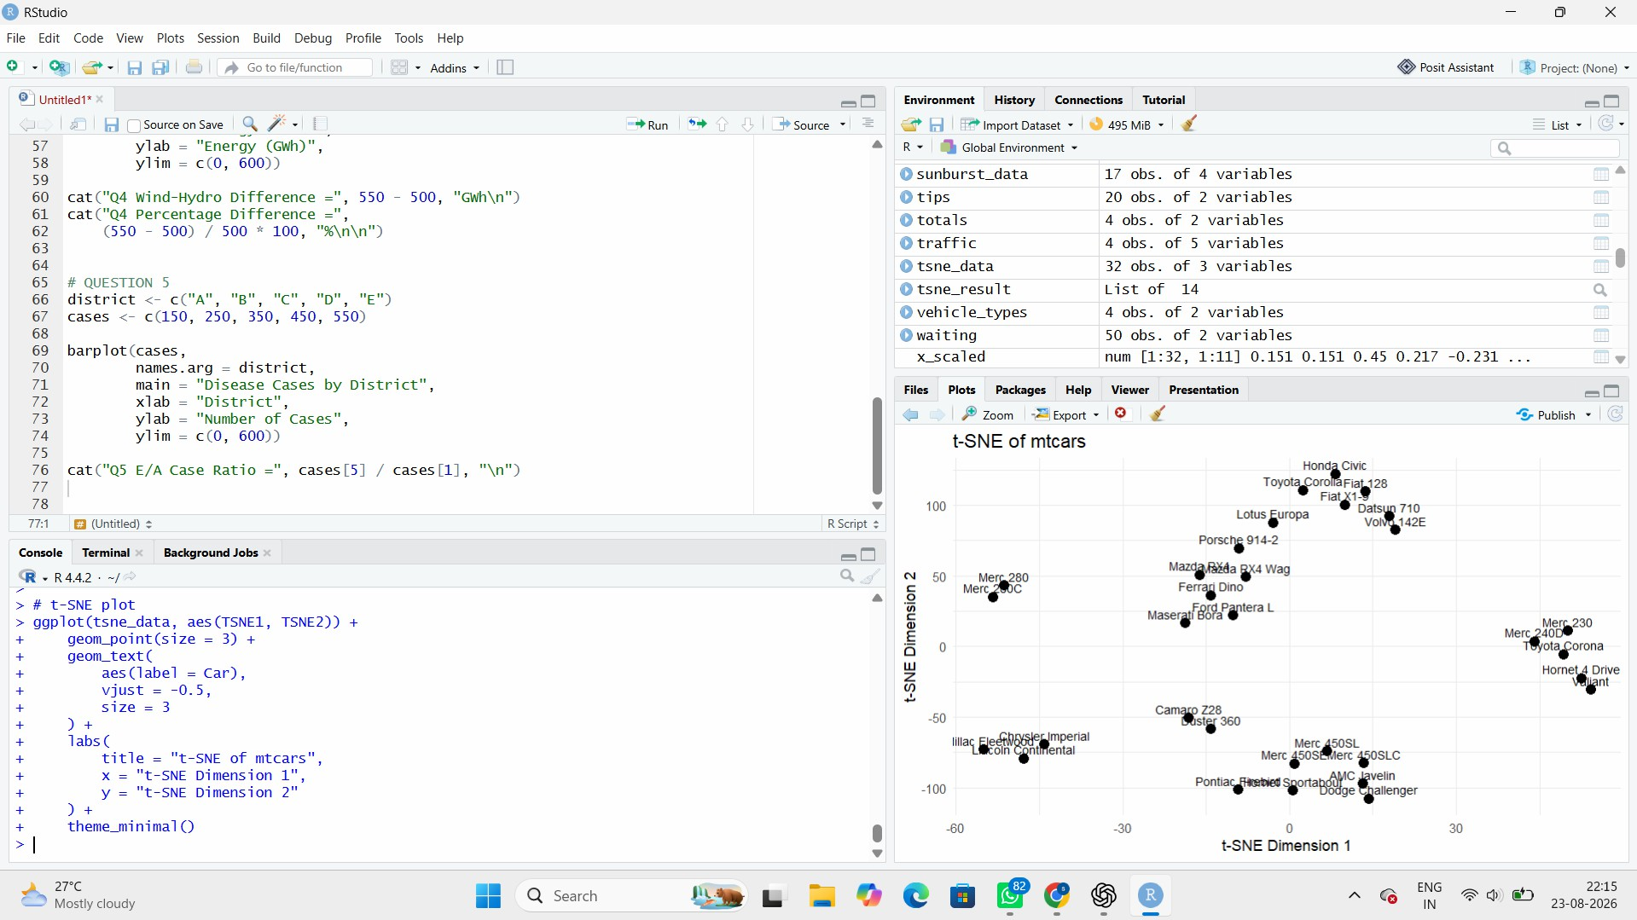

PCA vs t-SNE

PCA t-SNE

Linear
dimensiona lity reduction
Non-linear
dimensionality reduction

Easy to interpret
Mainly used for visualization

Preserves major global variation
Good at showing local clusters

Deterministic Depends on settings/random seed

Useful for explaining
Useful for discovering

variance groups

Conclusion

PCA is better when we want interpretable dimensions and explained variance. t-SNE is useful for discovering local clusters and nonlinear structures in high-dimensional data.

Question 4: Bubble Chart for Multivariate Paired Data
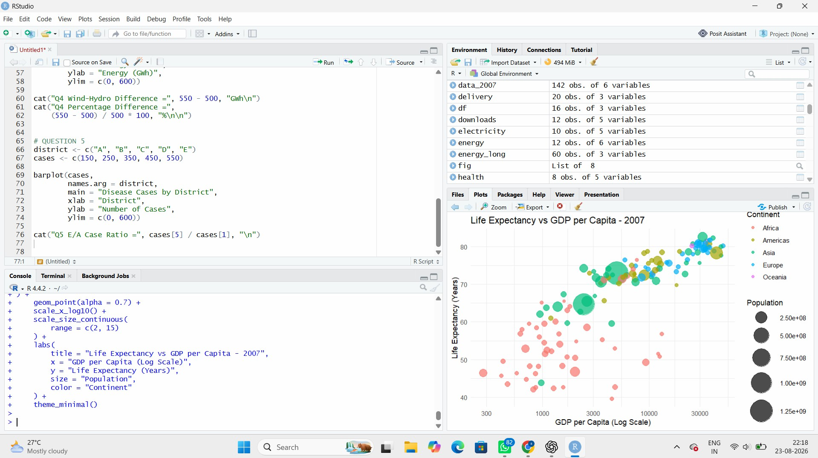

Interpretation

The plot generally shows a positive relationship between GDP per capita and life expectancy. Countries with higher GDP per capita tend to have higher life expectancy.
A visible pattern is that many African countries are concentrated toward the lower GDP and lower life-expectancy region, while countries in Europe and Oceania tend to appear toward higher life expectancy and GDP.
Some countries with very large populations appear as large bubbles, making them potential visual outliers in terms of population.

Question 5: Hexbin Plot vs. Network Graph

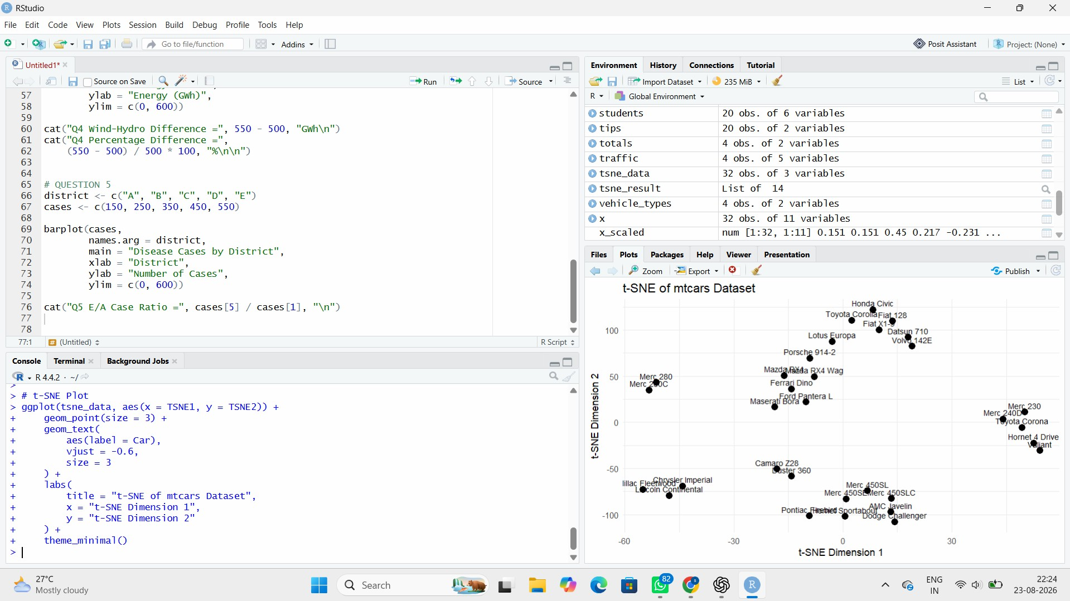

Why use a hexbin plot?
With 10,000 observations, a normal scatterplot can suffer from overplotting, where many points overlap.
A hexbin plot divides the plotting area into hexagonal regions and represents the number of observations in each region using shading/intensity. Therefore, it makes the density and structure of the data much easier to see.

Interpretation
The node with the highest degree centrality has connections to the largest number of other nodes. This suggests that the node plays an important or highly connected role in the network and may act as a central point for information or interaction.

